**USECASE DIAGRAM:**

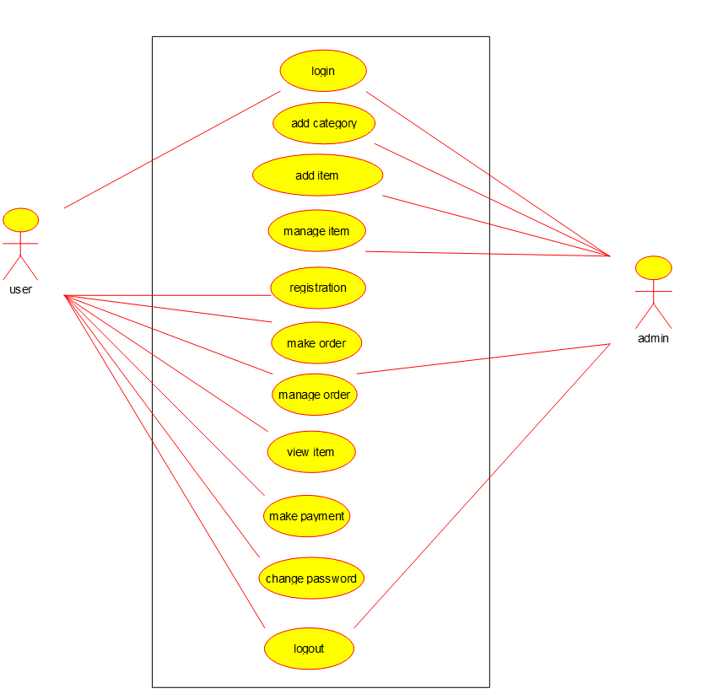

**CLASS DIAGRAM:**

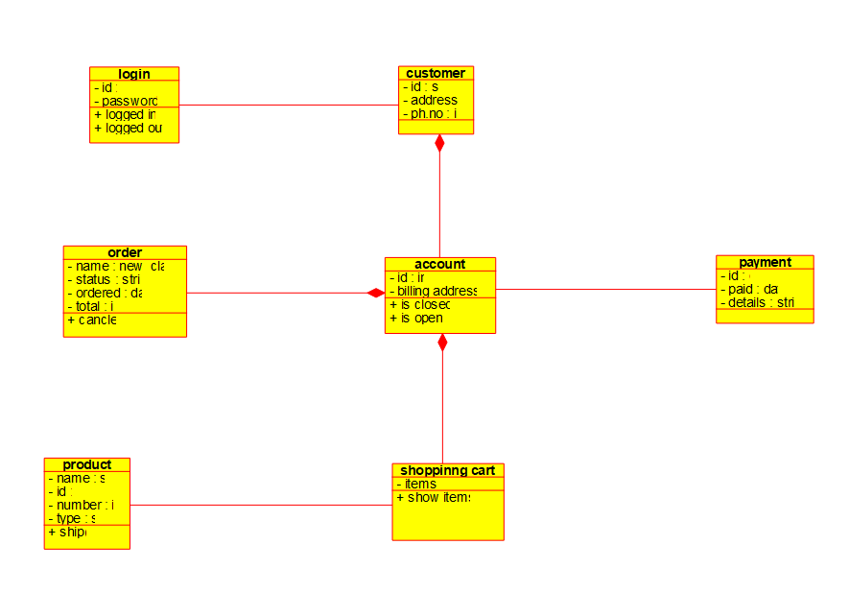**SEQUENCE DIAGRAM:**

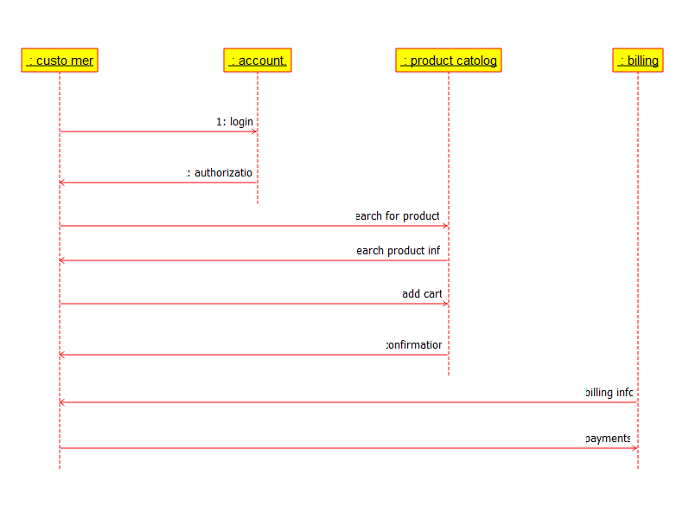

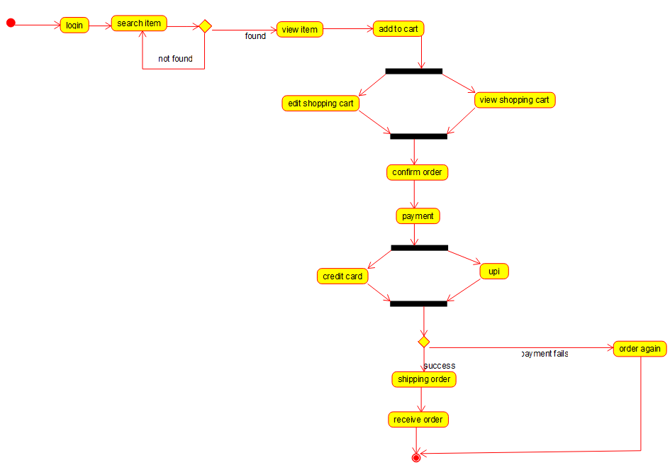**ACTIVITY DIAGRAM:**

**RESULT:**

Hence, the use-case diagram for online shopping system is drawn and verified successfully.